B) Uncomfortable Reactions – CISM / Peer Support
- Research shows that people will heal and recover faster from stress by responding to stress appropriately; this is the basis of peer support. Peer support can be as informal as "talking it over" with a trained peer or with a group. Even if you do not want to speak about the incident there is still value in listening to others speak about it. It is entirely voluntary, but highly encouraged to participate.
- CAP Peer Support can be considered emotional first-aid to help a CAP member’s normal coping skills. It is always confidential, supportive, and respectful; it is performed by a peer supporter – a CAP member just like you who knows how to get you the help you need.
- All people who undergo a traumatic or critical incident are affected. Talking and going through a CISM / Peer Support is a sign of strength and maturity because it means that you are taking an active role in your health.
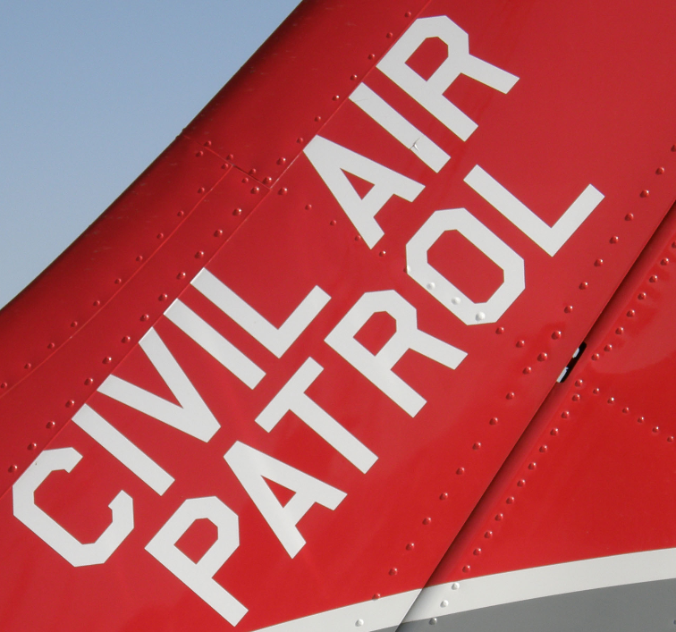
- CISM is a proven process that will help you heal and return to your previous state of health by talking (or listening if you choose not to talk) about the normal process your mind goes through after an incident or trauma.

Requesting Help (24x7)
- If you would like to speak with a CAP Critical Incident Stress Management / Peer Supporter contact your Chain of Command, Wing CISM Officer, OR call the CAP National Operations Center at 888-211-12812 (24x7) ext. 300 who will coordinate with the appropriate help that best fits your needs.
- If you want to speak confidentially with a suicide phone coach call the suicide prevention lifeline at 1-800-273-8266 or text for free at 838255.

This document may be used by CISM, Medical, Health Services, Nursing, or Safety Officers as one way to satisfy the monthly safety requirement.
4

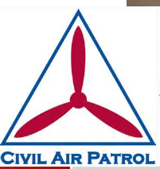
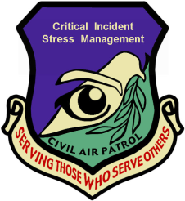

Critical Incident Stress Management (CISM) / Peer Support
Monthly Training – March 2015
Pre-Encampment Strategies for Success

Both during and after CAP Missions, CAP members report high stress rates. All people have reactions to stress after an incident or trauma – it is expected. CAP takes care of its members by offering the CAP Critical Incident Stress Management (CISM) Peer Supporters who explain how to get back to your regular levels of stress. It is not therapy, but rather a peer supported process of bouncing back.

Before going to an Encampment:
- Understand it will be an immediate, difficult challenge
- Be positive and motivated at all times
- Remember that you CAN COMPLETE IT. ENDURE.
- Remember to be humble and willing to take direction
- For some, Spiritual reactions (feeling disconnected)

A) Ways to Manage Stress:
- Physical Exercise promotes mental and physical well being as well as excellent stress management; if you are returning to exercise after a break, make sure your consult your healthcare provider and consider using the 7-minute workout which uses sequential exercises for 30 seconds with a 10 second break in between (creating a 7-minute workout or a 14-minute workout, if performed twice) summarized on the next page (additionally there are apps available for free).
1
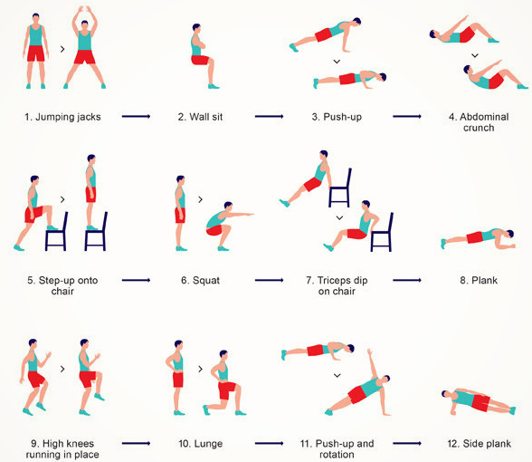

(public domain)

- Stress Guided Imagery is a technique where a relaxing image such as a favorite peaceful place is used to calm the mind and body. Think of a favorite place, envision yourself in that place, and relax your muscles from your neck to your toes several times a day to relax.

2
- Spend time with others: being around others who have experienced a similar event can be comforting. Just make sure that you do not spend all of your time speaking about the mission because that may limit growth from the mission and keep you “stuck” inside the mission mentality.
- Share your story: sharing your story to your loved ones or yourself through journaling or talking to yourself is important to process through the change that occurred.
- Relation Response is performed by slowly repeating a word or phrase like “slowdown, slowdown, slowdown”), while relaxing your muscles from your neck to your toes, while solely focusing on being more relaxed.
- Diaphragm Breathing is a technique where taking a few breaths relaxes your body. Step 1: breathe in through your nose as you count to 4 and expand your abdominal muscles. Step 2: Hold your breath for 1 second. Step 3: exhale through your mouth and silently count to 8; as you exhale, tighten your abdominal muscles. Repeat 3-4 times; many people report relief and peace.
- People who have faith should consider prayer as an excellent method to reduce stress and accept change. Local Religious or Spiritual leaders as well as CAP Chaplains can provide assistance with spiritual guidance, fellowship, and strategies for accepting change.
- Extra Sleep after a Mission: Getting extra sleep for a night or two is helpful to “reset” an overtired sleep clock. Many people in their daily life remark that poor sleep is one of the most common reasons for a negative mood. Techniques include:
  - No caffeine, nicotine, large meals, bright lights (to include tablets or computers), or exercise for 3-hours before bedtime.
  - Consider earplugs while sleeping (ensure you can hear the smoke or intruder alarm).
  - A short nap is fine; limit daily naps to 30-45 minutes.
3

